VILLAGE OF VICTORY
Upcoming Schedule of Meetings and Events
~ MAY 2019 ~

Village Board of Trustees Meetings:
Monthly Board Meeting ~ May 14, 2019 at 7:00pm
Second Tuesday of Each Month, unless otherwise rescheduled

**Junk Week** May 6th – 10th All items must be out by May 5th

Happy Memorial Day ~ CLOSED ~ May 27, 2019
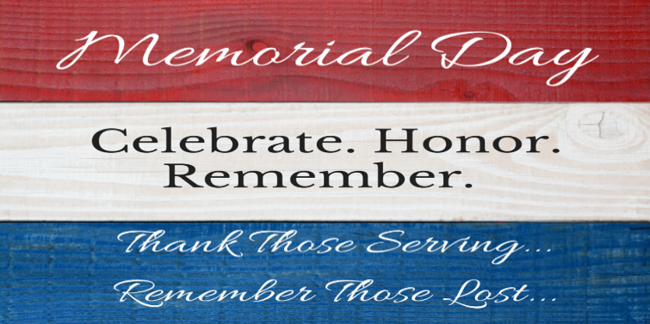

Village Zoning Board of Appeals Meeting
Monday, May 13, 2019 at 6:30pm

Village Planning Board Meeting
Tuesday, May 21, 2019 at 6:30pm

Joint Water Department Meeting
Schuylerville Victory Board of Water Management
Monday, May 20, 2019 at 7:00pm in Victory

We Accept Payments and Correspondence in the Drop Box
A reminder that payments must be received in the office by 5pm on the last day of the invoice due date to be considered on time.
We also accept the postmark date as the paid date.
For garbage stickers, include a self-addressed stamped envelope for return.
LAST DAY TO ACCEPT SEWER BILLS IN VILLAGE OFFICE
FRIDAY, MAY 17, 2019
After that, any outstanding amount will be levied onto the village tax bill June 1st

